Gradient Descent:

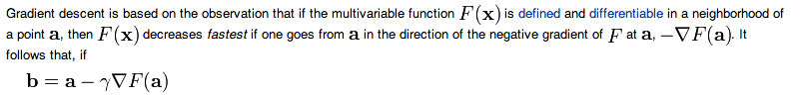

Exponential Families:

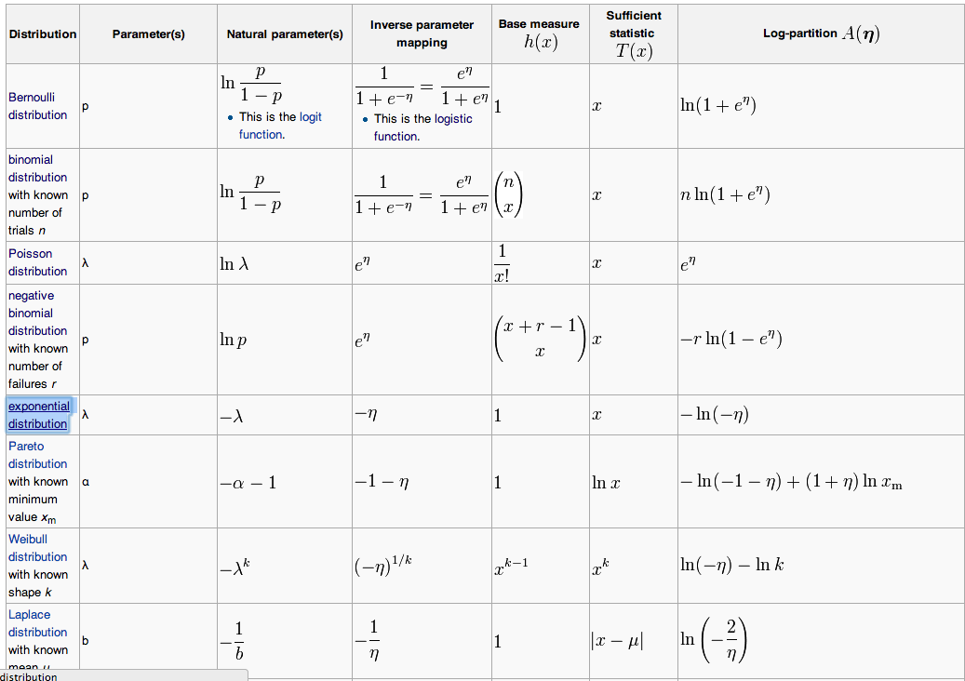

Exponential Family for Binomial:

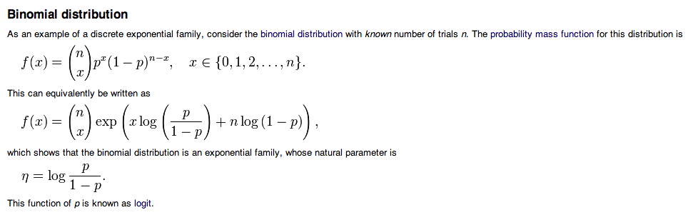

Other version:

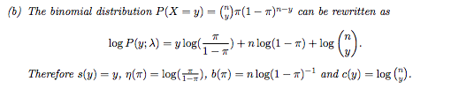

For Normal:

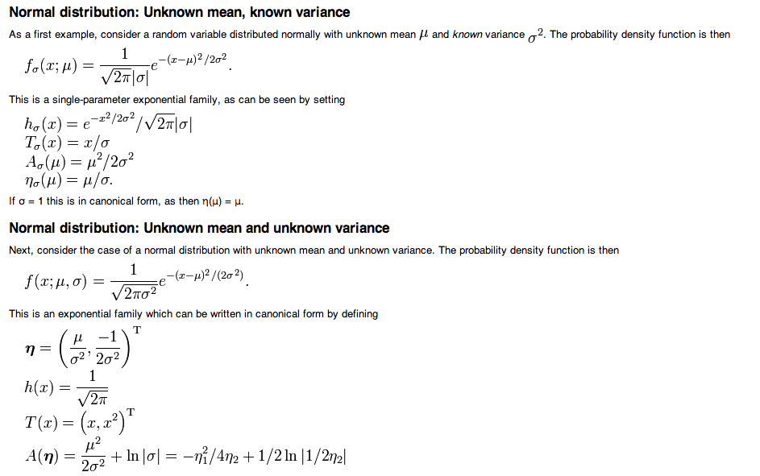

Likelihood function:

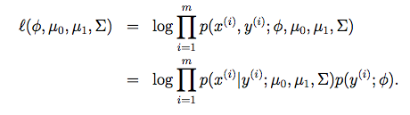

Product Rule for matrices:



